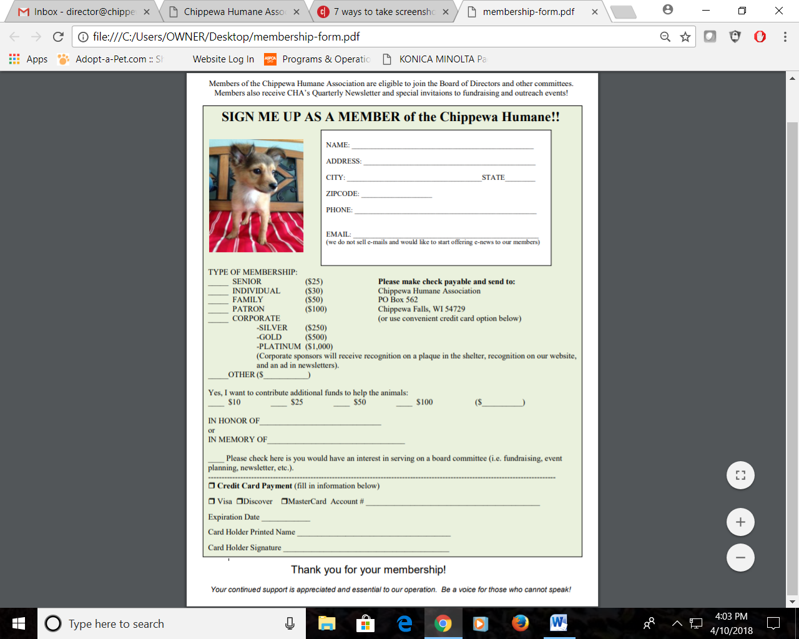

**CVC code (3 digits on back)** ______________